**Exercise 1: Implementing the Singleton Pattern**

**CODE:**

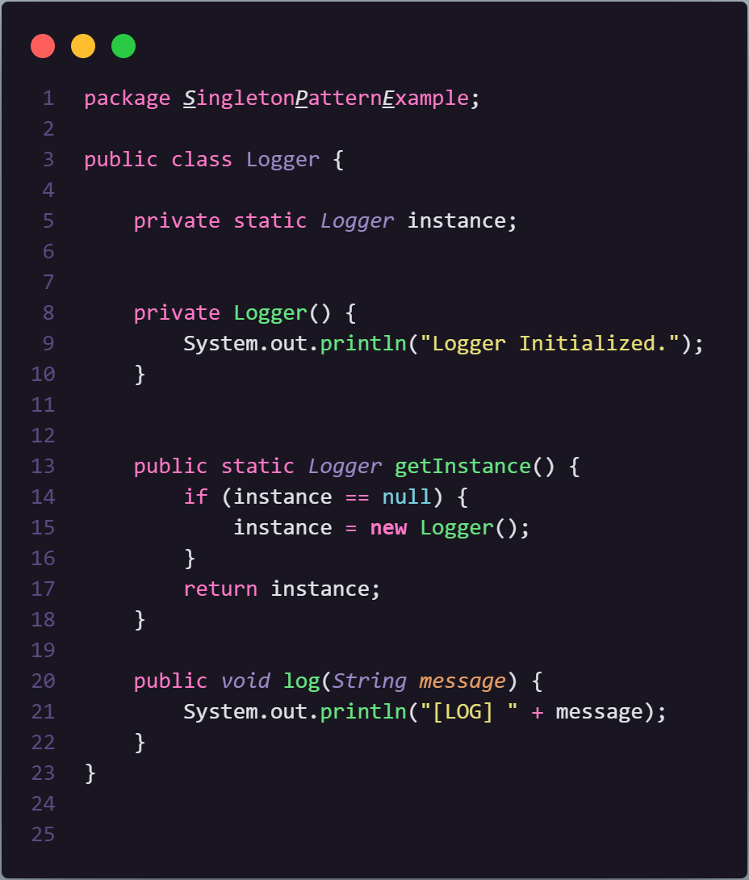

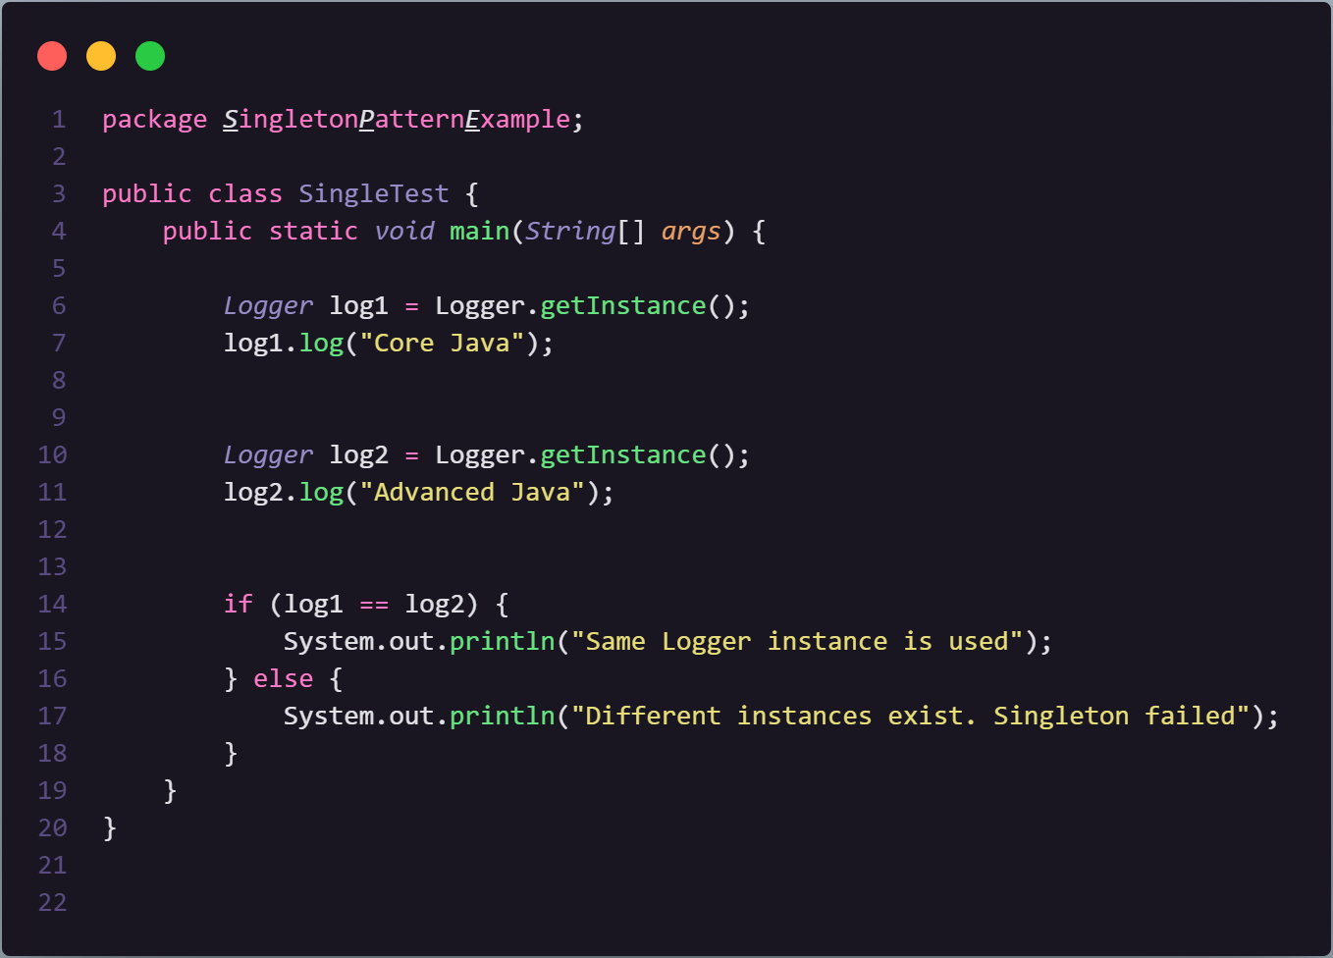

**OUTPUT:**



**Exercise 2: Implementing the Factory Method Pattern**

**CODE:**

**Document Interface (Supertype)**

**// Document.java**

public interface Document {

*void* open();

}

**Document Classes:**

**// DocumentFactory.java**

public abstract class DocumentFactory {

    public abstract *Document* createDocument();

}

**// WordFactory.java**

public class WordFactory extends *DocumentFactory* {

    public *Document* createDocument() {

        return **new** WordDocument();

    }

}

**// PdFactory.java**

public class PdfFactory extends *DocumentFactory* {

    public *Document* createDocument() {

        return **new** PdfDocument();

    }

}

**// ExcelFactory.java**

public class ExcelFactory extends *DocumentFactory* {

    public *Document* createDocument() {

        return **new** ExcelDocument();

    }

}

}

**Concrete Document Classes**

**// WordDocument.java**

public class WordDocument implements *Document* {

    public *void* open() {

        System.out.println("Opening a Word document.");

    }

}

**// PdfDocument.java**

public class PdfDocument implements *Document* {

    public *void* open() {

        System.out.println("Opening a PDF document.");

    }

}

**// ExcelDocument.java**

public class ExcelDocument implements *Document* {

    public *void* open() {

        System.out.println("Opening an Excel document.");

    }

}

**Testing the Factory Method Implementation:**

public class TestFactory {

    public static *void* main(*String*[] *args*) {

*DocumentFactory* wordFactory = **new** WordFactory();

*Document* wordDoc = wordFactory.createDocument();

        wordDoc.open();

*DocumentFactory* pdfFactory = **new** PdfFactory();

*Document* pdfDoc = pdfFactory.createDocument();

        pdfDoc.open();

*DocumentFactory* excelFactory = **new** ExcelFactory();

*Document* excelDoc = excelFactory.createDocument();

        excelDoc.open();

    }

}

**OUTPUT:**

